**GOVERNMENT SERVICES PORTAL**

***SUBMITTED BY:***

NACHIKETH JANAPAREDDY

17BCB0056

***SUBMITTED TO:***

**PROF. GOPINATH.M.P**

**Project Report**



# 1. INTRODUCTION

## 1.1 MOTIVATION

The purpose of this project is to simplify the procedure for applying for government approved identity cards and other services linked with it. With the increasing population, it has become extremely difficult for the government to provide people with the basic government identity cards in a given time. This in turn forbids the citizens from availing the services that require those identification cards as the proof. In order to tackle this problem, we have come up with an online solution to this problem. The advancement of technology can be a boon in this case. Our project aims at delivering an online platform for customers to apply for government identity cards and other government services linked with the identity cards.

## 1.2 AIM

To retrieve one’s adhaar card details and link them to all other services the government provides such as driving license and passport.

## 1.3 OBJECTIVES:

* Provides the users with a portal for easing the process of document application
* Provision for application of various government documents such as aadhar card, passport, etc.
* Provision for services associated with each of the above government documents
* Provision for banking services like account-to-account transfers after applying for a bank account.
* Provision for car rental services after applying for a driving license.

# 1.4 OVERVIEW OF THE SYSTEM

The project aims at building a website for providing the people with an easy connection to avail the government issued identity cards and avail other services like banking easily. The website is a combination of many such services so as to keep all the records of customer together. The website designed will be free for use to everyone and there will not be any subscription charges to use these services.

This website takes in the user’s Aadhar data at the time of sign-up. If the user doesn’t have the details, it will provide an application form to fill the aadhar details which will be verified by the system administrator. After log-in, users will be able to apply for passport, driving license and bank account.

# 2. SPECIFIC REQUIREMENTS

## 2.1 SOFTWARE REQUREMENTS

After creating the basic platform for the website the system requirements we desired to have in this project were as follows:

* A basic operating system .
* A text editor to create all the web pages
* To create the HTML and CSS pages we used Atom text editor.
* And to create all the database table we used Mongo DB
* To connect the frontend and the backend we used JavaScript
* Images from Google to make this website have a good interface
* And Bootstrap for the Index page to be created in the website

`***3. OVERALL DESCRIPTION***

**SCHEMA-**

**Adhar (adhar_id, NAME,AGE, USERNAME, DOB);**

**Driving_ license (license _no, adhar_id, date_issued, vehicle_type);**

**Passport (passport_id, adhar_id, date_issued, nationality);**

**Entity relation diagram-**

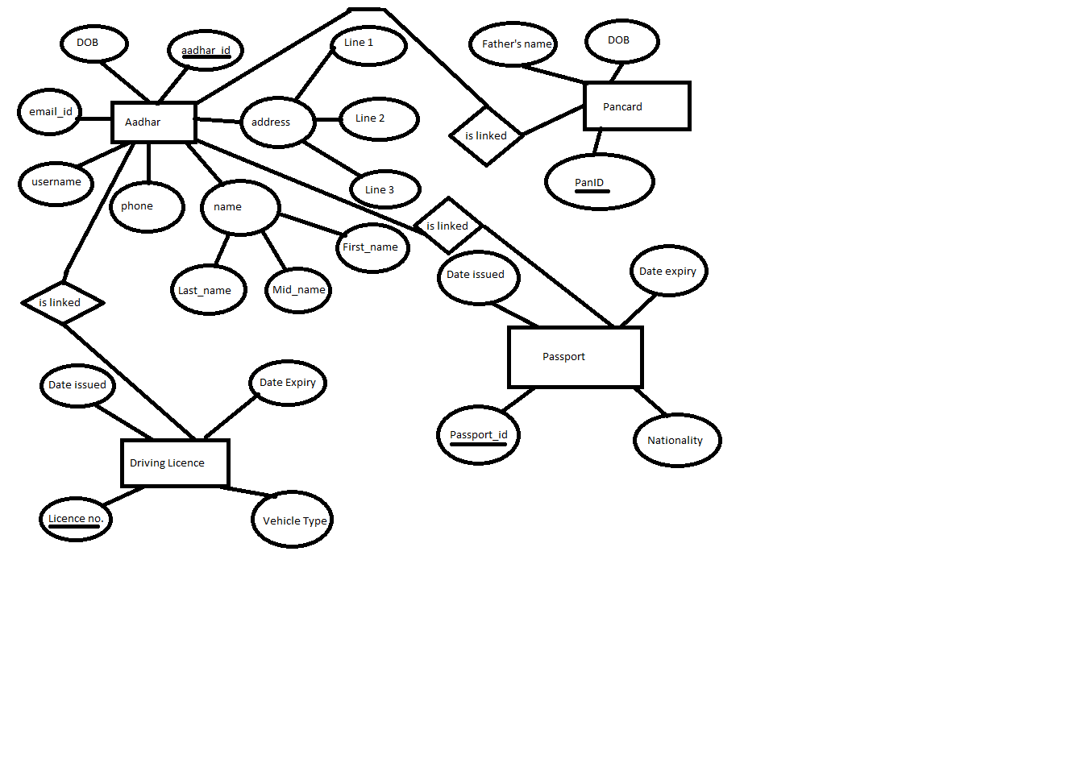

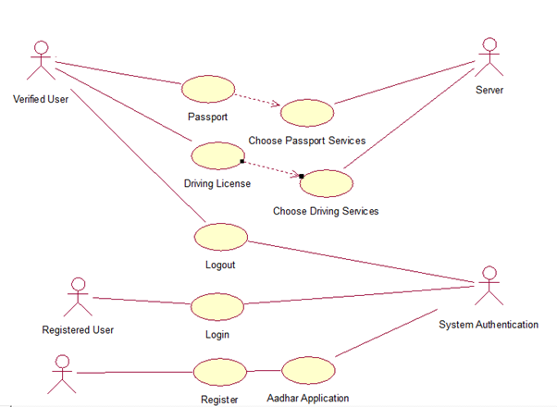

New User

*USE CASE DIAGRAM*

|  |  |
| --- | --- |
| USE CASE ID | 1 |
| USE CASE NAME | REGISTER NEW USER |
| SUMMARY | THE SYSTEM WILL REGISTER NEW USER INTO THE DATABASE ALONG WITH THE DETAILS OF THE USER SUCH AS:   * NAME * ADDRESS * PHONE * EMAIL * USERNAME * AGE |
| PRECONDITIONS | IN ORDER TO REGISTER, THE USER SHOULD HAVE A VALID EMAIL ID AND A VALID MOBILE NUMBER. |
| SUCCESS END CONDITION | ON SUCCESSFUL COMPLETITION OF THE REGISTRATION PROCESS USER IS PROMPTED WITH A SUCCESS MESSAGE FOLLOWED BY AN APPLICATION FORM TO FILL AADHAR DETAILS OR TO REGISTER FOR AADHAR CARD. |
| FAILED END CONDITION | REGISTRATION FAILS WHEN ANY OF THE CUSTOMER DETAILS ARE NOT VALID INCLUDING EMAIL ID AND MOBILE NUMBER |
| PRIMARY SECONDARY ACTORS | NEW USER AND SYSTEM AUTHENTICATION ARE THE PRIMARY AND SECONADARY ACTORS RESPECTIVELY IN THIS USE CASE. |
| DESCRIPTION | |  |  | | --- | --- | | STEP | ACTION | | 1 | NEW USER ENTERS THE WEBITES | | 2 | USER FILLS IN THE DETAILS FOR REGISTERING ON THE WEBSITE | | 3 | ON SUCCESSFUL COMPLETITION, AADHAR DETAILS ARE REQUIRED TO BE FILLED | | 4 | IF AADHAR IS NOT AVAILABLE, AADHAR APPLICATION FORM IS TO BE SUBMITTED | |

|  |  |
| --- | --- |
| USE CASE ID | 2 |
| USE CASE NAME | REGISTERED USER |
| SUMMARY | THE USER WILL HAVE TI FILL THE PEROSNAL DETAILS TO LOG-IN TO THE SYSTEM (SUCH AS EMAIL-IS, MOBILE NUMBER AND PASSOWRD) |
| PRECONDITIONS | THE USER SHOULD HAVE REGISTERED WITH THE WEBSITE. USER CANNOT LOGIN IF HE IS NOT REGISTERED |
| SUCCESS END CONDITION | WHEN THE LOG-IN IS SUCCESSFUL, USER IS REDIRECTED TO A NEW PAGE WITH HIS NAME DISPLAYED ON TOP. |
| FAILED END CONDITION | IN CASE OF WRONG DETAILS GIVEN AS INPUT, AN ERROR MESSAGE IS DISPLAYED WHICH STATED INVALID CREDENTIALS. |
| PRIMARY SECONDARY ACTORS | REGISTERED USER IS THE PRIMARY ACTOR. SYSTEM AUTHENTICATION ACTS AS THE SECONDARY ACTOR. |
| DESCRIPTION | |  |  | | --- | --- | | STEP | ACTION | | 1 | USER ENTERS THE WEBSITE | | 2 | USER GOES TO THE LOG-IN PAGE | | 3 | USER INPUTS THE CREENTIALS FOR LOGIN | | 4 | SUCCESFUL LOGIN REDIRECTS TO A NEW WEBSPAGE WITH THE SERVICES PORTAL FOR THAT PARTICULAR USER. | |
| USE CASE ID | 3 |
| USE CASE NAME | DRIVING LICENSE SERVICES |
| SUMMARY | THE LOGGED-IN USER CLICKS ON THE DRIVING LICENSE SERVICES. IF THE USER HAS NOT FILLED THE DRIVING LICENSE DETAILS, HE IS PROMPTED TO FILL THE DETAILS. IF THERE IS NO DRIVING LICENSE DETAILS FOR THE CUSTOMER, HE CAN APPLY FOR A DRIVING LICENSE.  IF THE USER HAS THE DRIVING LICENSE, ACCEPT THE DETAILS AND UPDATE THE DATABASE.  IF THE USER HAS ALREADY FILLED THE DETAILS, HE IS GIVEN THE OPTION TO CHANGE THE DATABASE. |
| PRECONDITIONS | THE USER SHOULD BE A REGISTERED USER AND HE SHOULD BE LOGGED IN TO THE SCREEN. |
| SUCCESS END CONDITION | ON SUCCESSFUL COMPLETITION, SERVICES ASSOCIATED WITH DRIVING ARE SHOWN SUCH AS LICENSE RENEWAL, CAR RENTAL AND SO-ON. |
| FAILED END CONDITION | IN CASE OF ANY INVALID INPUT, AN ERROR MESSAGE IS SHOWN WHILE FILLING THE FORM ITSELF. |
| PRIMARY SECONDARY ACTORS | THE REGISTERED USER IS THE PRIMARY ACTOR IN THIS CASE. |
| DESCRIPTION | |  |  | | --- | --- | | STEP | ACTION | | 1 | USER LOGS IN TO THE WEBSITE | | 2 | USER OPTS FOR DRIVING LICENSE SERVICES | |
| EXTENSIONS | |  |  | | --- | --- | | STEP | BRANCHING ACTION | | 1 | IF NO DRIVING DETAILS AVAILABLE, PROMPT USER TO FILL IT. | | 2. | IF USER WANTS TO UPDATE, UPDATE THE LICENSE DETAILS | | 3 | DIRECT THE USER TO DRIVING SERVICES SUCH AS CAR RENTAL, LICENSE RENEWAL AND SO-ON | |

|  |  |
| --- | --- |
| USE CASE ID | 4 |
| USE CASE NAME | PASSPORT SERVICES |
| SUMMARY | THE LOGGED-IN USER CLICKS ON THE PASSPORT SERVICES. IF THE USER HAS NOT FILLED THE PASSPORT DETAILS, HE IS PROMPTED TO FILL THE DETAILS. IF THERE IS NO PASSPORT DETAILS FOR THE CUSTOMER, HE CAN APPLY FOR A PASSPORT.  IF THE USER HAS THE PASSPORT, ACCEPT THE DETAILS AND UPDATE THE DATABASE.  IF THE USER HAS ALREADY FILLED THE DETAILS, HE IS GIVEN THE OPTION TO CHANGE THE DATABASE. |
| PRECONDITIONS | THE USER SHOULD BE A REGISTERED USER AND HE SHOULD BE LOGGED IN TO THE SCREEN. |
| SUCCESS END CONDITION | ON SUCCESSFUL COMPLETITION, SERVICES ASSOCIATED WITH PASSPORT ARE SHOWN SUCH AS PASSPORT RENEWAL, VISA APPROVAL AND SO-ON. |
| FAILED END CONDITION | IN CASE OF ANY INVALID INPUT, AN ERROR MESSAGE IS SHOWN WHILE FILLING THE FORM ITSELF. |
| PRIMARY SECONDARY ACTORS | THE REGISTERED USER IS THE PRIMARY ACTOR IN THIS CASE. |
| DESCRIPTION | |  |  | | --- | --- | | STEP | ACTION | | 1 | USER LOGS IN TO THE WEBSITE | | 2 | USER OPTS FOR PASSPORT SERVICES | |
| EXTENSIONS | |  |  | | --- | --- | | STEP | BRANCHING ACTION | | 1 | IF NO PASSPORT DETAILS AVAILABLE, PROMPT USER TO FILL IT. | | 2. | IF USER WANTS TO UPDATE, UPDATE THE PASSPORT DETAILS | | 3 | DIRECT THE USER TO PASSPORT SERVICES | |

## FUNCTIONAL REQUREMENTS

Atom is used as the editor to develop webpages. The webpages have been built using HTML, CSS and JAVASCRIPT. The back end comprises of maintaining individual profile using Node JS and Mongo DB. The laptop will serve as a server. Node js will host the server on the laptop itself and the database will also be stored in the laptop only.

The pages are connected through hyperlinks as the main file is stored on the server. The homepage will have a slide show to attract customers to use this portal.

## Mongo DB

### MongoDB is a document database with the scalability and flexibility that you want with the querying and indexing that you need

* MongoDB stores data in flexible, JSON-like documents, meaning fields can vary from document to document and data structure can be changed over time
* The document model maps to the objects in your application code, making data easy to work with
* Ad hoc queries, indexing, and real time aggregation provide powerful ways to access and analyze your data
* MongoDB is a distributed database at its core, so high availability, horizontal scaling, and geographic distribution are built in and easy to use
* MongoDB is free and open-source.

**FUTURE SCOPE:**

This project when is done with Desktop and Web Application ready 100%, An android app will be designed soon with same features as taken in this software design.

Conclusion:

In conclusion, the DBMS system provides data abstraction, and it removes structural and data dependence from the system. Which in turn this makes things a lot easier on the end user. Data Storage Management The DBMS creates and manages the complex structures required for data storage, thus relieving the need of defining and programming physical data characteristics. It provides a mechanism for management of permanent storage of the data. The internal schema defines how the data should be stored by the storage management mechanism and the storage manager interfaces with the operating system to access the physical storage.

A modern DBMS system provides storage not only for the data, but also for related data entry forms or screen definitions, report definitions, data validation rules, procedural code, structures to handle video and picture formats, and so on.(Myreadingroom.co.in, 2016).6